Q. Why digital design was not popular in early days?
Ans. “Digital Design” was not popular in early days because of following reasons:-

1. There were no CAD tools available for verification and design of VLSI digital circuits consisting of more than 100,000 transistors.

2. There were no standard hardware description languages available to describe digital circuits.
Q. What are the advantages of designing?
Ans. Advantages of Designing:
1. Designing is useful in quick implementation, testing and useful in complex circuits.
2. Designing reduces the design cycle.
3. Using CAD tools, circuits can also be simulated and then synthesized.
Q. What are CAD tools? Name different types of CAD tools available for digital system.
Ans. CAD tools refer to software tools that aid the development of circuits, systems and other things. CAD tools are the use of computer technology to aid in design of a product. CAD is a most accurate description of this modern way.
CAD Tools for digital systems: Different CAD Tools for digital systems are:
1. Schematic entry tools
2. HDLS
3. HDL compilers, simulators and synthesis tools
4. Simulators
5. Test benches
6. Timing Analyzers and verifiers.
Q. What are Hardware Description Languages?
Ans. Hardware Description Languages are those languages that can be used to model a digital system at many levels of abstraction. These allow defining the digital circuits in terms of register transfer levels. HDL can describe the circuit’s operation, its design and tests to verify its operation by means of simulation. HDL’s are used to design two kinds of systems.

1. These are used to design an integrated circuit such as a processor.
2. These are involved in programming the programmable logic devices, such as the PLA, FPGA etc.
Q. What important role do HDL’s play in IC design these days?
Ans. Hardware Description Language is the standardized language used to describe digital circuit. It allows the designers to model the concurrency of processes found hardware elements for IC design.
1. HDLs can be used to describe design at various levels of abstraction, ranging from system level to silicon level.
2. It can be used as an exchanger media between chip vendors and CAD tool users.
3. HDLs are programming languages that have been optimized for digital circuit design and modeling.
4. It can standardize the data transfer between various design phases.
5. It also simplifies the documentation.
Q. State the advantages of HDL’s.
Ans. HDL’s have many advantages compared to traditional schematic-based design.
These are:
1. We can verify the design functionality early in design cycle written as an HDL description,
2. It reduces the cost in non-recurring engineering.
3. Designing with HDLs is analogous to computer programming.
4. HDL compiler provides logic synthesis and optimization, so we can automatically convert a HDL description at a gate level implementation.
5. It is easy to make changes and debug the design.
6. It describes design in text format.

Q. What different levels of hardware abstraction are there? What levels of these, can be simulated with VHDL?
Ans. Hardware description languages are used to model a digital system at many levels of abstraction. The various levels of abstraction are:
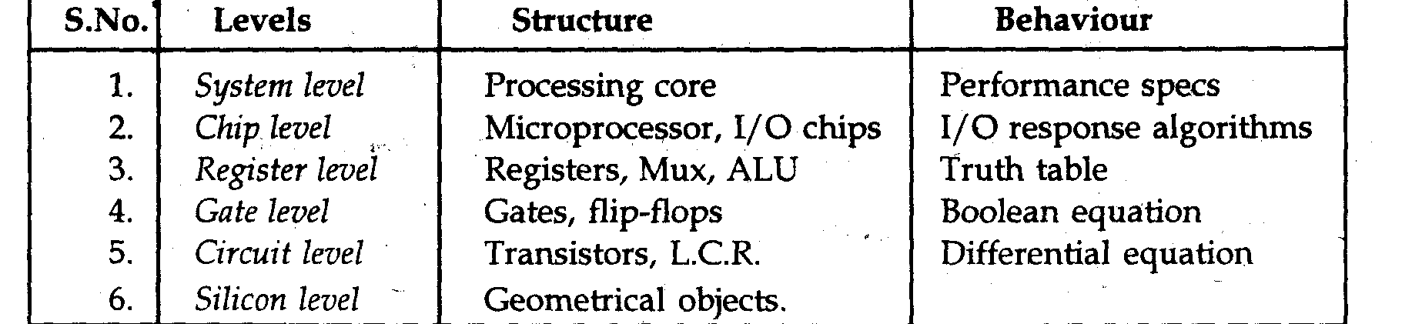
VHDL can simulate digital hardware systems from algorithm level up to the gate level (i.e. from highest abstraction level to gate level). It cannot simulate the transistor level models. For such kinds of models, we use verilog which provide accurate results.

Q . What does VHDL stands for? Why HDL is used?
Ans. VHDL is acronym for “very high speed integrated circuit hardware description language”. Use of HDL : HDL is used because:
1. It is easy to design, implement, test and document increasingly complex digital system.
2. For million gate ICS, schematics and Boolean equations are inadequate.

Q. What do you mean by an entity?
Ans. Entity: It is hardware abstraction of digital system that can be as simple as logic gate or as complex as complete electronic system. It is modulled using an entity declaration and one or more architecture body. The entity declaration specifies the name of an entity being modulled and list of interface port.
Syntax:
Entity entity name is [generic (generic declaration)] [Port (Port declaration);] end [entity name];
Q. What do you mean by an architecture?
Or
What are 3 levels of Architecture description?
Ans. Architecture : An architecture description is used to specify the internal view of digital system. The internal view describes the functionality or structure of a device.
Levels of architecture : The three levels of an architecture body are:
(i) Behaviour Style: It is the highest level of abstraction in VHDL. It describes the functionality of the circuit as a set of sequential assignment statements.
(ii) Structua1 Style: It describes the internal view of a digital system as a set of interconnected components.
(iii) Data flow Style : This style of modeling describe how data flow through the system or as a set of concurrent assignment statement.

Q. Explain entity and architecture declaration.
Ans. Entity Declaration : Entity declaration specifies the name of the entity that is being modeled. The list of interface ports that is the signals through which the entity communicates with the other models in the external environment are also specified. They may be input, output, bidirectional or of buffer type.
Example: Entity of an AND gate is defined as:
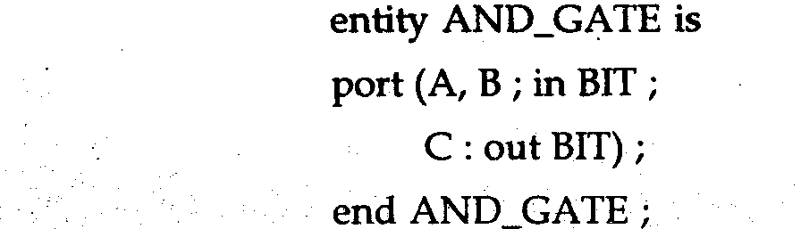
The entity AND_GATE has two input ports A and B and one output port C specified by m and out in the declaration The ports are of BIT type z e , 0 or 1 can be assigned to the ports
From the entity declaration, we observe that only the name of the entity and the interface ports are declared. The internals of the entity are not specified in it.
Architecture Declaration: Architecture declaration, describes the internal description of the design unit or tells the composition of the design. Each entity has at least one architecture and an entity can have many architecture. Architecture can be described using structural, dataflow behavioral or mixed style. Architecture can be used to describe a design at different levels of abstraction like gate level, RTL or behavior level.

Syntax: architecture architecture_name of entity_name.
architecture_declarative_part;
begin
end architecture_name;
Here, we should specify the entity name for which we are writing the architecture body. The architecture statement should be inside the begin and end keyword. Architecture declarative part may contain variables, constants or component declaration.
Q. What is meant by instantiating a component?
Ans. Component Instantiation : The purpose of instantiating a component is to define a design hierarchy or build a net list in VHDL by referencing a previously defined hardware component in the current design, the current level of hierarchy and referencing components not defined in VHDL, such as components from a library.
The component instantiation statement introduces a subsystem declared elsewhere, either as a component or as an entity/architecture pair.
There are three forms of component instantiation:
1. Instantiation of a component;
2. Instantiation of a design entity;
3. Instantiation of a configuration;

Q. Discuss about structural models.
Ans. Structural Model : Structural style of model is used to describe a circuit in terms of its components. Structural mode has a set of interconnected components. It is essentially the text version of a schematic. Structure can be used to create a very low level description of a circuit or a very high level descriptions(such as block diagram). For a higher level circuits-structure might simply be used to segment the design description into parts. Structure level VHDL features components and configurations are useful for managing complexity.
Q. Write about behavioral model.
Ans. The behavioural model specifies the behaviour of an entity as a set of sequential statements that are executed in the specified order. This set of sequential statements, which are specified inside a process statement, do not explicitly specify the structure of the entity but its functionality. A process statement is a concurrent statement that can appear within an architecture body.
A process statement consist of declarative part and statement part. The statement comes in statement part are sequential statements and are executed sequentially. The list of signals specified within the parent his is after keyword process constitutes a sensitivity list, and the process is stopped wife never, there is an event on any signal in this list.

Q. Compare signals and variables.
Ans. Comparison of signals and variables:
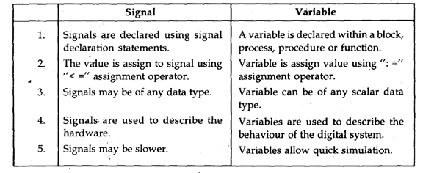
Q. Compare different styles of model?
Ans. Comparison of different styles of model
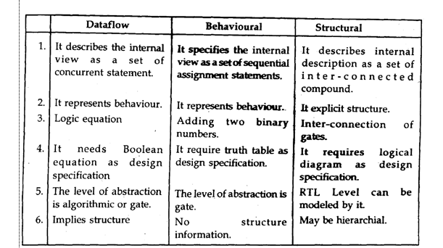

Q. What is the difference between simulation and synthesis?
Ans. Simulation: It is used to verify the functionality of the circuit. It is basically of two types: 1 Functional simulation 2 Timing simulation
Synthesis: It basically converts VHDL or VERILOG description to a set of primitives or components. It creates a representation of a system at a lower level design abstraction from a higher level representation

Q. What are the various data objects in VHDL?
Ans. A data object holds a value of specified type. It is created by means of an object declaration .e.g. variable sum : Integer range 0 to 50;
Different data objects in VHDL. The various classes of data Object in VHDL are:
(i)Constant declaration
(ii) Variable declaration
(iii) Signal declaration
(iv) File declaration

Q. Explain various types of data object.
Ans. A data objects hold a one or more value of specified type. It is created by means of an object declaration e.g. constant delay : time : = ions;
The creation of data object in above example called delay can hold value of type time, and the value assigned to the object at start of simulation is ions.
The various types of data object are:
1. Constant declaration, 2. Variable declaration, 3. Signal declaration, 4. File declaration
1. Constant declaration : An object of constant class can hold single constant value of given type The value is assigned to it before simulation starts and cannot change during the duration of simulation.
Syntax of Constant
Constant constant_name : type : = value;
e.g. Constant bus_width integer: = 8;
2. Variable declaration : An object of variable class can hold a single value of specified type, but different values can be assigned to variable at different time.
Syntax of Variable:
Variable variable_name : type: = initial value: e.g. Variable sum: Integer range 0 to 55: = 5;
This declaration declares the object ‘SUM’, which can hold a value of ‘integer’ typeand initial value assigned to object is 5.
3. Signal declaration : An object of signal class can hold a list of values (i.e. more than one value), that includes initial value, current value and a set of possible future values that appear on the signal.
Syntax:
Signal signal name : type : = initial value;
e.g. Signal clock_delay; time: = 2ns;
4. File declaration: An object belongs to the file class holds a sequence of values,which an be read or write to the file using read procedure and write producer.
Syntax:
File identifier : Subtype_indication [open mode] is string expression;
e.g. File stimulus: text open write_mode

Q. What are constants? How are constants declared?
Ans. Constant: A constant can hold a single value of a given type and its value cannot be changed during simulation, once it is defined for the design.
Constants may be explicitly declared or they may be sub-elements of explicitly declared constants, or interface constants. The constant declaration contains one or more identifiers, a subtype indication and an expression, which specifies the value of the constant, declared in the particular statement. e.g. Constant width: integer: = 8;constant x : Std_logic: = 16;

Q. What are the different logic levels available in standard logic type?
Ans. Standard logic type is composed of a different logical levels and is defined as:
Type STD_ULOGIC is
‘U’ — Uninitialized — Forcing unknown
‘0’ — Forcing 0
‘1’ — Forcing 1
‘Z’ — High impedance
‘X’— Weak unknown
‘L’— Weak 0
‘H’ — Weak 1
‘-‘— Don’t care

Q. Write about logical operators
Ans. Logical Operators Such operators are meant for performing certain computation to one or more operands
Types of logical operators the various logical operators are
AND, OR, NAND, NOR, XOR, XNOR, NOT
These operators are accepted for the predefined types BIT and BOOLEAN. The result of logical operation must have the same type as its operands.
Q. What are the different arithmetic and logic operators? List them based on the priority.
Ans. The operators are means for constructing expression in VHDL. It also specifies the computation to be performed on operands to evaluate results. The various predefined arithmetic and logic operators with their priority are as follows:
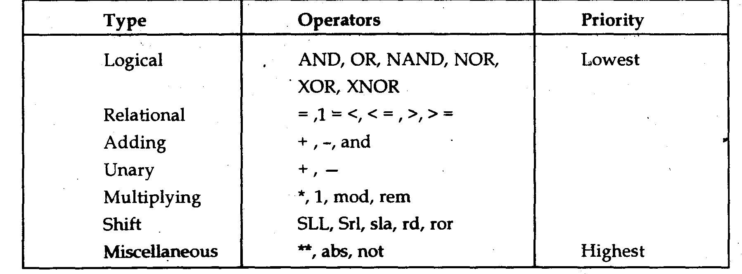

Q. What are the two main classes of statements used in VHDL descriptions?
Ans. Main statement used in VHDL descriptions. There are two main classes of statements used in VHDL descriptions. These are:
1. Sequential statements
2. Concurrent statements
Q. What is a statement? How are they classified?
Ans. Statement : A statement is a construct used to specify one or more actions to take place in a hardware description
Statements in VHDL can be classified as shown in fig. below:

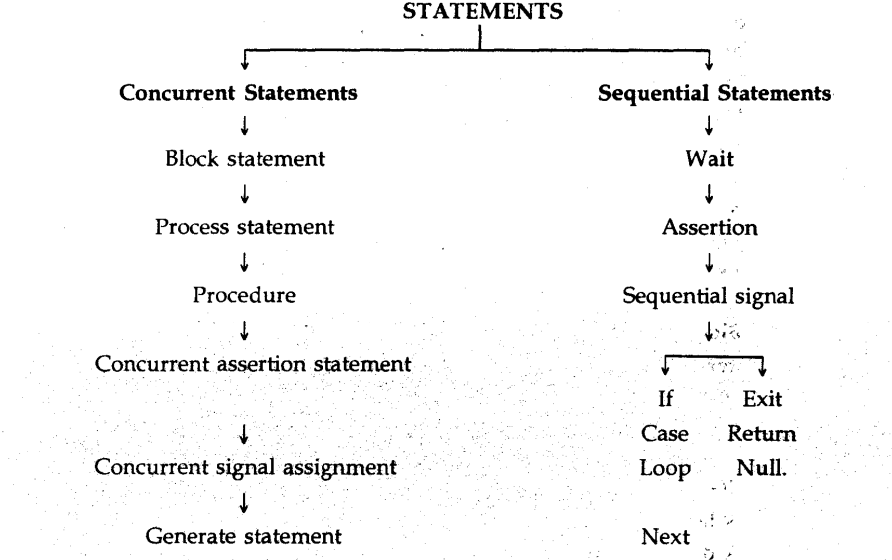

Q. Write a short-note on process statement.
Or
What is process statement?
Ans. Process Statement : A proces statement is a concurrent statement which contains a set of sequential statements. A proc statement describes the functionality of a portion of an entity in sequential terms.
The syntax is: -
[Process label] Process [(sensitivity_list)I
process_item_declarations
begin
Sequential statements;
end process [process-label];
A label, which is optional names the process:
• The process statement in VHDL is used to describe the sequential operations in a design.
The process statements represent the behaviour of same portion of the design.
It consists of sequential statements whose execution is made in the order defined by the user. The process declarative part defines local items for the process and within it may declare subprograms, types, subtypes, constants, variables, etc. whereas signals or shared variables are not allowed to be declared inside processes.
Q. What do you mean by sensitivity-list?
Ans. Sensitivity list: It contains a set of signals to which the process is sensitive.
Syntax:
(signal name a, signal name b )
The sensitivity list is a way of specifying signals, each time an event occurs on any of the signals in the sensitivity list, the statements within the process are executed in a sequential order.

Q. “Process will execute in the absence of sensitivity list”: True or False. Support your answer?
Ans. A process will execute in absence of sensitivity list, this statement is true. Initially, if the sensitivity list is provided, the process will execute once and then it will suspend until an event occurs on any of the signal specified in the sensitivity list. If the
sensitivity list is not provided the process still executes and will not suspend rather go into infinite loop. It should be noted that the process actually never terminates, it is either in executing state or in suspended state. So, in order to avoid it to go into infinite loop, we can use wait statement explicitly which can suspend process statement according to conditions given (i.e. Boolean equation or time expression or sensitivity list.)
Q. 9. What are signal assignment and variable assignment statements?
Ans. Signal Assignment Statement: Signal assignment statements are used to assign values to signals.
Syntax:
Signal object c = expression [after delay value];
Signal assignment statement can be defined within a process or outside a process. If it occurs inside a process, it is considered to be a sequential signal. When a signal assignment statement appears outside the process, it is called concurrent signal assignment statement.
Variable Assignment Statement: A variable is assigned a value using the variable assignment statement that typically has the form:
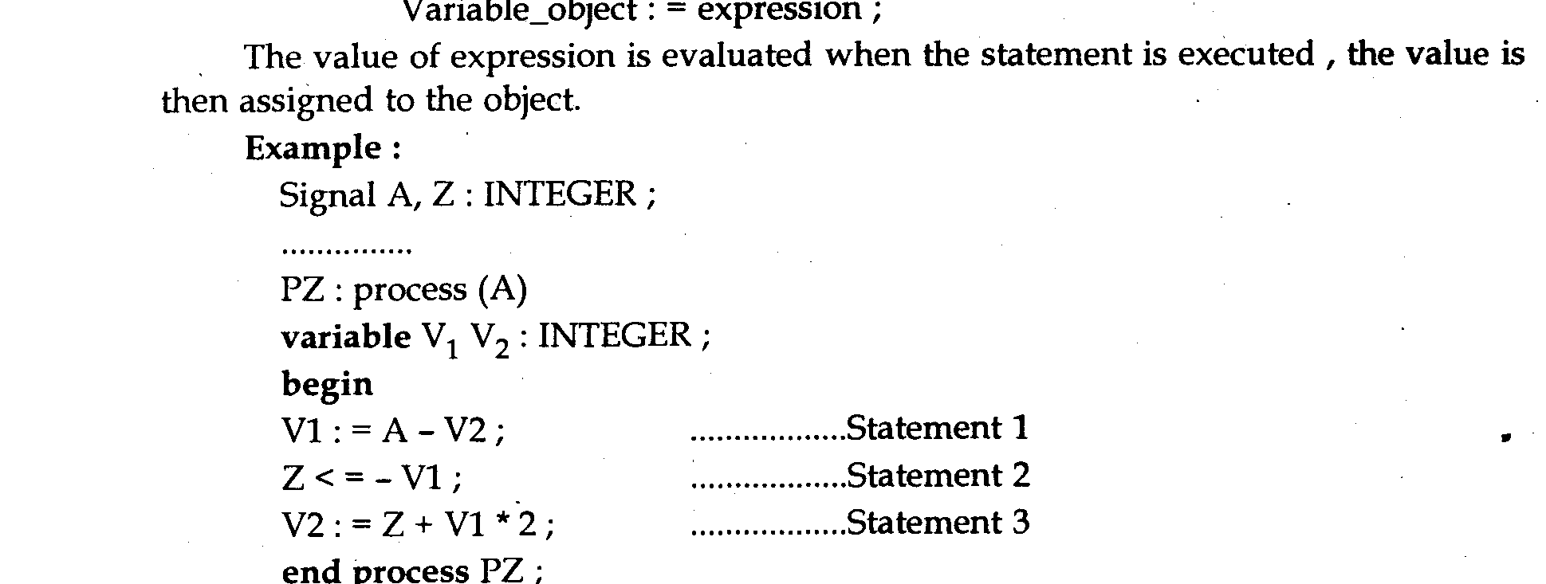
Process:
If an event occurred on signal * at time T1, and variable V2 was assigned a value, say 10, in statement 3, then next time an event occurs on A at time T2, the value of V2 used in statement, would still be 10.
A variable can also be declared outside a process or subprogram. Such a variable can be read or updated by more than one process. These are called shared variables.

Q. What is the prime use of signal? Quote suitable example.
Ans .Use of signals It holds a list of values including the current value of signal and a set of possible future value that are to appear on the signal
— Signals are used to model wires and flip-flops.
— Signals are used to model inherent hardware features such as concurrency, inertial character of signals propagation, buses with multiple driving sources, etc.

Q. Explain concurrent statement?
Ans. Concurrent statement it describes the functionality of digital structures. These statements can appear anywhere in architecture part and are executed in asynchronous manner, i.e. they order-independent. Process statements and block statements are concurrent statements.
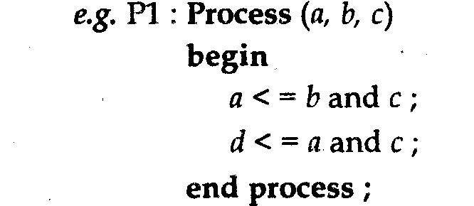
Q. Explain conditional statements with example.?
Ans. Conditional statements are used to check a condition. These are included within the ‘Process’ statement. VHDL allows the use of conditional statements in an architecture declaration based on behaviour of module.
Conditional statements used in VHDL are:
1. If-then Else statements
2. Switch/case statements.
Examples:
If-then-Else statements Case Statements
Syntax
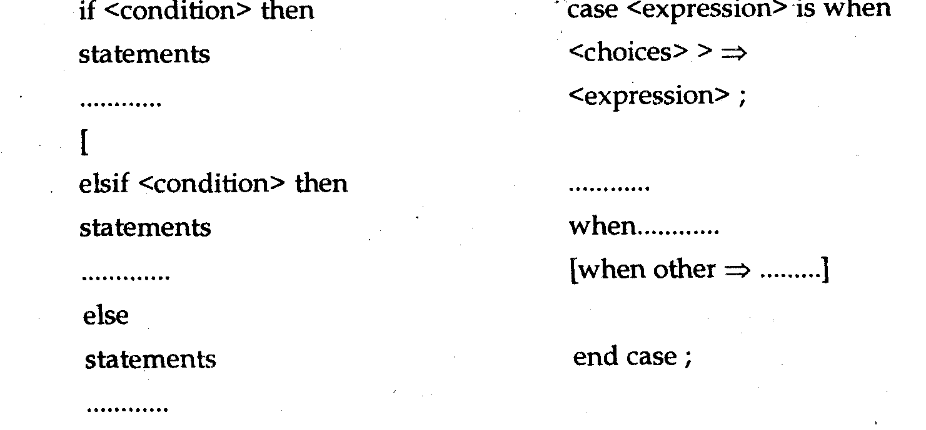
end if
Q. What are sequential statements?
Ans. Sequential Statements: A set of statements that are executed in a sequence, is called sequential statements. Sequential statements occur inside processes and subprograms. Each statement is executed in the same order as it is specified i.e. sequential statements are order-dependent sequential statements depending on their operation and are categorized as follow:
• Assignment Statements
• Variable Assignment Statements
• Signal Assignment Statements
• If Statements
• Case Statements
• Loop Statements
• Next Statements
• Exit Statements
• Subprograms
• Wait Statements.
• Null Statements.

Q. What is the logic equivalent of CASE and IF ELSE statement?
Ans. The logic equivalent for CASE and IF ELSE statements can be explained by example of 2 x 4 decoder:
Using CASE statement
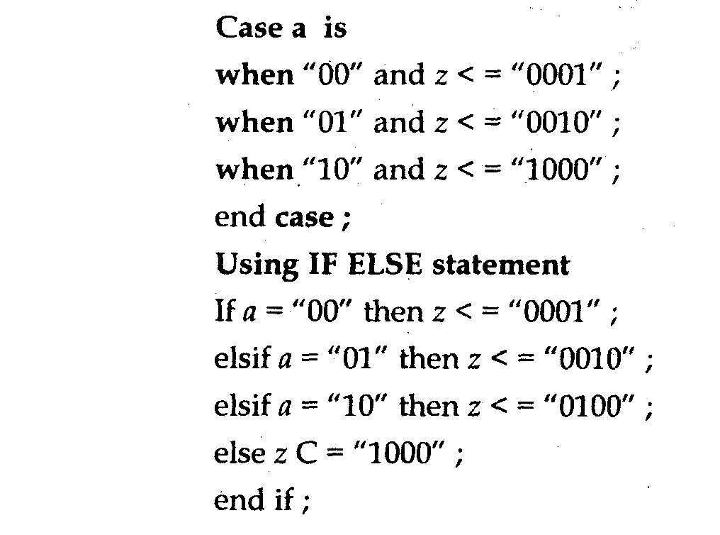
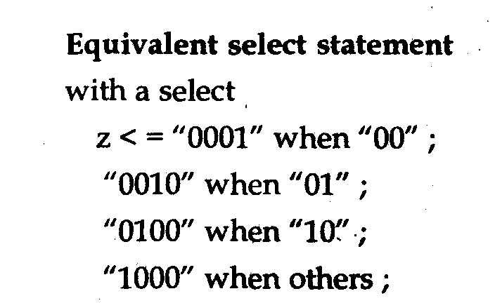

Q. Define test Bench. What is the purpose of test bench?
Ans. Test Bench a test bench is model used to exercise and verify the correctness of a hardware model. VHDL language provides us the capability of writing test bench models in the same language. So, to verify the proper operation of the circuit over time in response to input stimulus, writing a test-bench is needed.
Purposes of Test Bench: A test bench has following three main purposes:
1. To generate stimulus for stimulation (waveform)
2. To apply this stimulus to the entity which is to be tested and then the output response are collected.
3. To compare output response with expected values.

